**Work Breakdown structure**

The work breakdown structure will be numbered according to task(Tn)

T1. Requirement Elicitation

T2. Software Design

T3. Coding of UI Main Page

T4. Coding of Alphabet Page

T5. Embedding sound into the Alphabet Page

T6. Testing of the Alphabet Page

T7. Coding of Number Page

T8. Embedding sound into the Number Page

T9. Testing of the Number Page

T10. Coding of Animal Page

T11. Embedding sound into Animal Page

T12. Testing of Animal Page

T13. Deliver

Tasks, Duration and Dependencies

|  |  |  |
| --- | --- | --- |
| Task | Duration | Dependencies |
| T1 | 6 days |  |
| T2 | 4 days | T1 |
| T3 | 1 day | T1,T2 |
| T4 | 4 days | T1,T2,T3 |
| T5 | 2 days | T1,T2,T4,T5 |
| T6 | 10 days | T1,T2,T3,T4,T5 |
| T7 | 4 days | T1,T2,T3 |
| T8 | 2 days | T1,T2,T3,T7 |
| T9 | 10 days | T1,T2,T3,T7,T8 |
| T10 | 4 days | T1,T2,T3 |
| T11 | 2 days | T1,T2,T3,T10 |
| T12 | 10 days | T1,T2,T3,T10,T11 |
| T13 | 1 day | T1,T2,T3,T4,T5,T6,T7,T8,T9,T10,T11,T12 |

**Activity network**

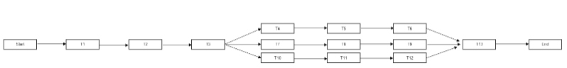

Gantt chart

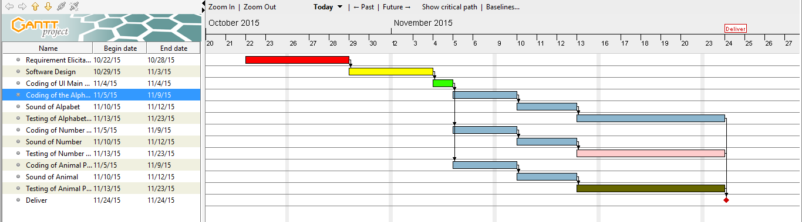

**Risk analysis**

|  |  |  |
| --- | --- | --- |
| RISKS | PROBABILITY | EFFECT |
| Key staff leaving the team before project completion | Moderate | Catastrophic |
| Users ability to communicate requirements of project to the project team | High | Serious |
| Power outages | High | Tolerable |
| Inappropriate choice of software development process | Low | Serious |
| Underestimating size of project (in terms of work to be done) | High | Serious |
| Reliability of supporting software to be used | Very Low | Tolerable |
| Inaccurate estimation of budget for project | High | Serious |